South Jordan Elementary Code of Conduct

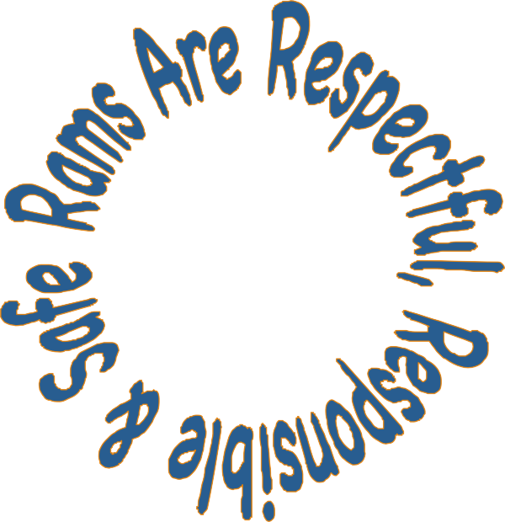

Welcome to school, students and parents! We are looking forward to a fabulous year together! Here is a copy of South Jordan Elementary School’s Code of Conduct.

South Jordan Rams are:

Respectful
Accountable
Motivated
Safe

POLICIES
All JSD policies can be viewed online at https://policy.jordandistrict.org/

Dress Code (AS419)
Students shall dress in a manner that shows respect for the educational environment and befits the day’s activities. Student clothing and jewelry should be safe and free from disruptive pictures or messages. Flip-flops are a safety concern (PE and Recess). Students are encouraged to wear footwear with an enclosed toe and heel strap at a minimum. Hats may not be worn in the school. Tank, halter, or spaghetti-strap tops may be worn with a shirt underneath that has a collar and sleeves. Shorts/Skirts should reach mid-thigh when the student is sitting.

Student Dress Code Info Sheet

Drug and Alcohol Policy (AS90)
Illegal drugs, alcohol and tobacco are not permitted on our school campus. With the exception of asthma inhalers, students may not have prescription or over-the-counter medications in their possession. Prescription and/or over-the-counter medications may be administered by a parent during the school day or by trained staff in the main office with a written directive from a physician (see the office for paperwork).

Exclusion Policy Summary (AS67 NEG)
Jordan School District students and employees are entitled to a learning/working environment free from unlawful and violent acts. Acts of violence, use or possession of a weapon or facsimile, criminal behavior, and gang activity in or about district schools, property, or activities shall be dealt with in accordance with district policy and the law.

Attendance (AA432)
Regular attendance is key to academic success. Utah’s Compulsory Education Law states that all school age children must be in attendance at school unless there is a valid and legitimate excuse (Utah Code 53-A-11-101). You will receive an automated phone call if your child was marked absent for the day. Please contact the main office if your child will miss a day of school.

Bicycles and Scooters
Bicycles and scooters may be ridden to school, but they must NOT be ridden on the school grounds or in the crosswalks. The bike racks at the back of the school are for students in grades 1-6. Bike racks are available near the main entrance for patrons and Kindergarten students. Helmets are strongly encouraged!

Electronics (AS67)
Electronic games, IPODs, pagers, laser pointer toys, etc. are not allowed at school. Students who carry cell phones must turn them off and put them away during class time. The teacher or the main office will hold electronic items confiscated for improper use until parents are able to pick them up.

Bullying and Cyberbullying (AS98)
Our school is committed to providing a safe and civil school environment in which all members of the school community are treated with dignity and respect. Bullying behaviors, by definition, run counter to this commitment. They are repetitive and include a wide range of unkind/disrespectful actions that negatively impact the bully as well as the bullied, resulting in the classic lose-lose scenario. At SJE, we are committed to teaching and living by the philosophy of Think Win-Win. Accordingly, we encourage all who believe they’ve witnessed or experienced bullying behavior to report it to a teacher or administrator. All reports will be investigated in good faith and addressed at the level necessary to correct the problem, up to and including student suspension/expulsion.

Definitions: Bullying occurs when a student, or group of students, repeatedly behave or speak in a way that belittles, scares, hurts, threatens or intimidates another person. These behaviors can look like:
- Verbal – teasing, name-calling, or purposefully belittling others
- Physical – hitting, shoving, tripping, poking, cornering, or otherwise physically harming others
- Visual – leering, exposing to harmful/embarrassing material, or making unkind/threatening gestures
- Emotional – the use of gestures, notes, rumors, or gossip to emotionally diminish or hurt others. May also include using relationships with friends as a hurtful tool
- Cyber – The use of media and/or electronic devices to humiliate, embarrass, threaten or hurt others

Student Responsibilities
If you feel you are being bullied, try the following:
- Tell the bully in clear terms to STOP. His/her unkind behavior is not funny, kind or welcome
- Walk away from the bully if he/she does not stop and report your concern to an adult (playground supervisor, teacher, counselor, principal and/or parent)

Parent Responsibilities
- Review this Code of Conduct with your child and make sure he/she knows what you expect and stand for as a parent
- If your child is a victim of bullying, support and encourage him/her through this difficult situation. Insist that your child report the concern to school staff and follow up with your child and school staff
- If your child has engaged in bullying at any level, team up with the school to help him/her recognize and put an end to the hurtful behavior

Teacher/Administrator Responsibilities
- Participate in annual training related to bullying issues
- Explicitly teach students what constitutes bullying and how to proactively deal with bullying behaviors
- Investigate all reports of bullying in good faith, communicate concerns with parents, and provide instruction/consequences as necessary to correct harmful behaviors

Elementary-age students are at a stage in life where they are learning critical academic and social skills. In many cases, students this age who exhibit bullying behaviors think they are being funny or playful, or are otherwise oblivious to the severity of their actions – for their own development as well as that of their victims. Ofttimes, with the support of parents, instruction and simple consequences are sufficient to correct the problem. Occasionally, more severe disciplinary measures are required. Depending on the history and severity of behaviors, consequences may range from something as simple as a conference with teachers/administrators to exclusion from school. No child will be allowed to persist in bullying behaviors at school.

Celebrating Great Kids
Student Conduct

Positive school behavior makes all the difference in the world. To help students learn and maintain good behavior, we will teach behavioral expectations for each area of the school, practice good citizenship at school and recognize students for their appropriate behavior.

R.A.M.S. Passes
Students will be given R.A.M.S. passes when they are “caught following the school expectations. Students will be able to redeem the passes in the office for a small prize.
Rocky Ram Leadership Award
Each grade level has a set of goals for their students to work on throughout the school year. Students should complete goals in the areas of Academics, Self, and Service.

Voice Level Key (For the Behavioral Expectations that follow)

- No Talking
- Whisper (Library Voice)
- Inside Voice (Normal Voice, Not Raised)
- Outside Voice (Loud Talk, Yelling, Laughter)

South Jordan Elementary Expectations for Behavior

 | Respectful | Motivated & Accountable | Safe
Arrival & Dismissal Voice 2 | - Use appropriate and friendly language  - Hold door for those behind you  - Walk your wheels on school property | - Use your assigned doors  - Arrive and leave on time  - Follow teacher on duty | - Follow adult directions  - Use cross- & sidewalks  - Walk wheels on cross-walks & school property  - Go straight to where you are expected
Hallway  Voice 0 | - Hold door for those behind  - Keep hands & feet to self  - Admire displays in hallways by looking, not touching | - Follow adult directions  - Stay with your class  - Go straight to your destination | - Walk facing forward  - Keep line straight  - Walk to the right
Playground  Voice 3 | - Play fairly & include everyone  - Share equipment  - Use appropriate and friendly language  - Keep hands and feet to self  - Use a respectful voice | - Put equipment away  - Respond to the whistle or bell  - Get permission to use the bathroom or get a drink | - Follow adult directions  - Follow game rules  - Use equipment appropriately  - Stay in your designated area  - Report unsafe equipment or people
Inside Recess  Voice 2 | - Play fairly & include all  - Share equipment and games  - Use appropriate and friendly language  - Keep hands and feet to self  - Use a respectful voice | - Follow adult directions  - Put materials away  - Get permission to use the bathroom or get a drink  - Respond to adult signals | - Follow game rules  - Walk in the building  - Stay in classroom or designated area  - Use materials appropriately
Cafeteria  Voice 2 | - Use appropriate and friendly language  - Wait in line patiently  - Keep hands and feet to self  - Be polite to adults | - Follow adult directions  - Raise hand for help  - Eat politely  - Leave your area clean  - Raise hand to be excused | - Walk quietly  - Carry tray with both hands  - Eat your own food  - Face table, feet on floor, bottom on bench
Bath- rooms Voice 1 | - Respect others’ privacy | - Flush, wash and leave  - Use soap and paper products appropriately  - Throw paper away  - Leave area clean and dry | - Get permission to use the bathroom  - Wash and dry hands  - Tell an adult about problems
Media Center Voice 1 | - Keep hands & feet to self  - Use appropriate and friendly language  - Share and take turns  - Listen to adults | - Follow adult directions  - Use equipment carefully  - Clean up after yourself  - Be polite in line  - Push in chair | - Walk in the media center
Computer Lab Voice 1 | - Keep hands & feet to self  - Use appropriate and friendly language  - Share and take turns | - Follow adult directions  - Finished assigned work  - Use equipment & materials responsibly  - Put materials away  - Push in chair | - Sit the right way  - Walk in the lab  - Use internet appropriately
Gym  Voice 3 | - Keep hands and feet to self  - Share and take turns  - Use appropriate and friendly language  - Encourage others | - Use equipment/materials appropriately  - Clean up after yourself  - Put materials away | - Follow adult directions  - Follow game rules  - Play with equipment appropriately  - Report unsafe equipment or people
Assembly  Voice 0 | - Enter and exit quietly  - Be silent during presentations  - Keep hands and feet to self  - Be a good audience | - Follow adult directions  - Listen to presenter(s)  - Wait to be dismissed | - Walk and sit facing forward  - Keep space between you and others  - Stay with your class
Office  Voice 2 | - Patiently wait for an adult to acknowledge you.  - Use kind words and actions | - Follow adult directions  - Use office phone with permission | - Get adults’ attention

Please read, sign, and return this signature page to your child’s teacher.

I know that my behavior matters. I agree to Be Respectful, Responsible and Safe.

Student signature Date

My child and I understand the behavior expectations for students at South Jordan Elementary.

Parent signature Date

